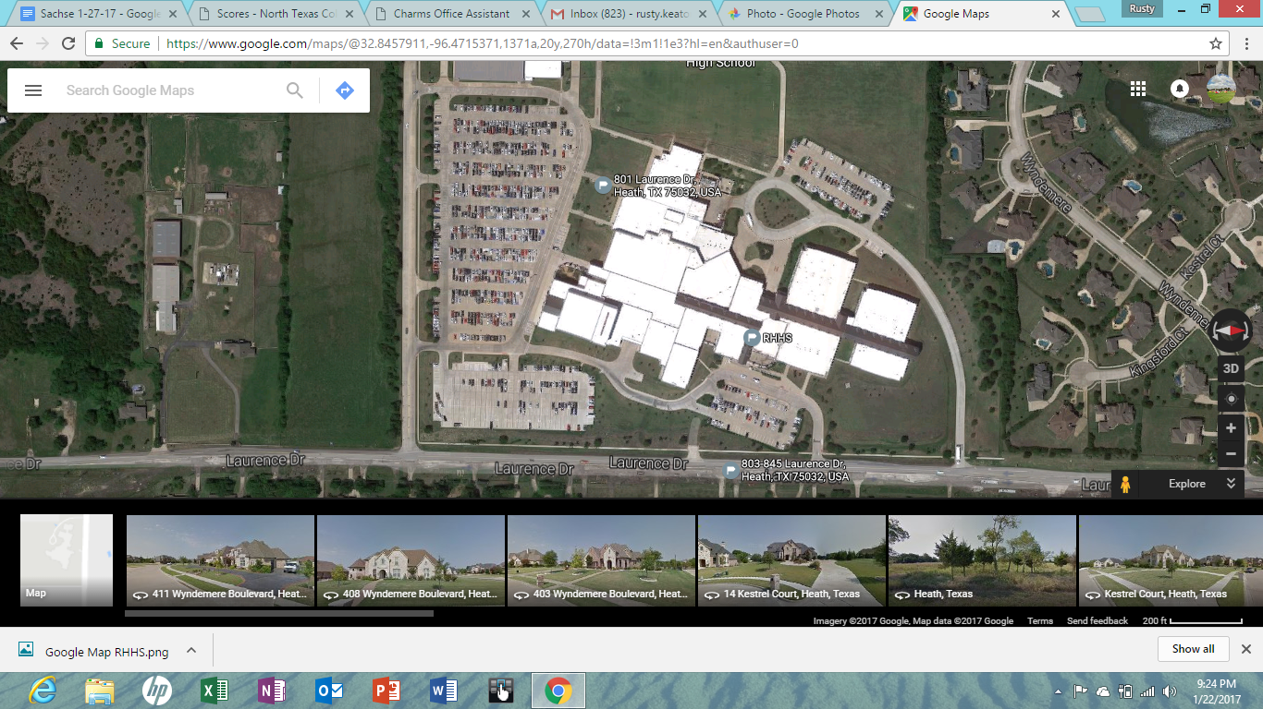

Bus Route to parking

Bus Route to Drop off

**Interstate 30**

**Spectator Entrance**

**Unit Check-In**

**NTCA Staff/Director Parking**

**Prop/Floor Drop Off**

**Spectator Parking**

**Bus Parking**